Deep Learning for Healthcare Specialization
Neural Networks in Applied Medicine. Learn the latest cutting-edge methods in Deep Learning for Medical Applications

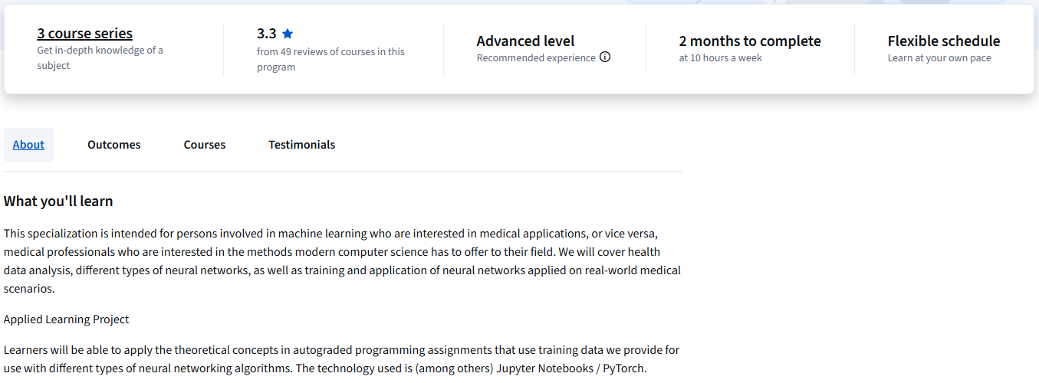

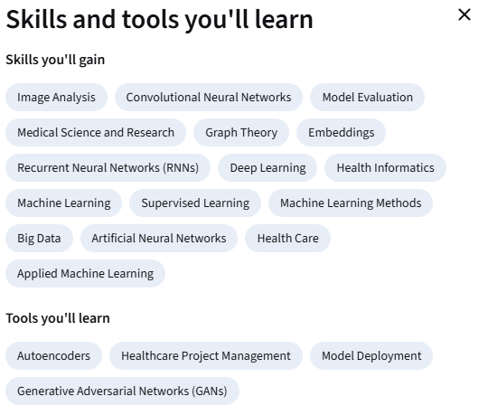
Specialization - 3 course series
This specialization is intended for persons involved in machine learning who are interested in medical applications, or vice versa, medical professionals who are interested in the methods modern computer science has to offer to their field. We will cover health data analysis, different types of neural networks, as well as training and application of neural networks applied on real-world medical scenarios.
Applied Learning Project
Learners will be able to apply the theoretical concepts in autograded programming assignments that use training data we provide for use with different types of neural networking algorithms. The technology used is (among others) Jupyter Notebooks / PyTorch.

